PROJECT WEGOTIT! Writing Efficiently with Graphic Organizers: Teachers Integrating Technology

Computer-Based Graphic Organizer User Manual

© George Mason University

4400 University Dr., MS 1F2

Fairfax, VA 22032

Phone 703.993.5256 • Fax 703.717.3681

This document was produced under U.S. Department of Education, Office of Special Education Programs **No. H327S120011.** The views expressed herein do not necessarily represent the positions or policies of the Department of Education. No official endorsement by the U.S. Department of Education of any product, commodity, service or enterprise mentioned in this publication is intended or should be inferred. This product is public domain. Authorization to reproduce it in whole or in part is granted.

# Overview of WEGOTIT and WEGO 1.0

Powered by Microsoft Word, WEGOTIT/WEGO 1.0 is a free technology-based graphic organizer for writing multiple essay genres, including persuasive essays, expository essays, and personal narratives with embedded Universal Design for Learning (UDL) features. Featuring a table-to-text graphic organizer scaffolding the writing process and mnemonic IDEAS to guide essay composition, WEGO 1.0 supports self-regulated learning strategies for writing, such as goal setting, self-instruction, self-monitoring, and self-evaluation.

Like all other WEGO tools, WEGO 1.0 offers several Universal Design for Learning (UDL) supports, which incorporate evidence-based educational practices and provide options for customizing access to information. Examples of UDL features include:

* Option for text-to-speech or Read Aloud (see Enable text-to-speech and Read Aloud)
* Audio comments
* Text hints
* Drop-down menus
* Color coding
* Prompts for monitoring progress

To learn more about other WEGO tools, visit <https://www.wegowriting.com>

# Software requirements for WEGO

WEGO 1.0 (WEGO) is an offline technology-based graphic organizer that is compatible with the following versions of Microsoft Word:

* Microsoft 365/Microsoft Word (desktop application)
* Microsoft Word 2010 (desktop application)
* Microsoft Word 2011 (desktop application)
* Microsoft Word 2013 (desktop application)
* Microsoft Word 2016 (desktop application)
* Microsoft Word 2019 (desktop application)
* Microsoft Word 2021 (desktop application)

Microsoft offers discounted pricing for accessing desktop applications for K-12 students and educators as part of their Microsoft 365 A3 plans; more information can be found at [Microsoft Office 365 Education](https://www.microsoft.com/en-us/education/products/office?msockid=3daaec77582d60b30431fffc59b96159%23tabs-pill-bar-oc3c0f_tab0).

WEGO cannot be used in the following applications:

* Word for the web (accessed via web browser)
* Google Docs
* Microsoft Word mobile application for iOS or Android

The entire functionality of the WEGO graphic organizer is contained within a single Microsoft Word file, which can be edited by the user. No internet access is required.

# WEGO permissions

In order to use WEGO, the following permissions may need to be configured in Microsoft Word.

ActiveX controls

WEGO uses ActiveX controls (also known as active controls or form blocks) to structure the graphic organizer so users can add text and get additional tips for writing. Some versions of Microsoft Word block ActiveX controls by default.

To enable ActiveX controls to use WEGO:

1. Open WEGO document.
2. Determine if ActiveX controls are blocked for this document. If they are, a notification will appear at the top of the screen that says **BLOCKED CONTENT: The ActiveX content in this file is blocked**
3. To enable ActiveX content, select **File > Options > Trust Center**
4. Open **Trust Center Settings**.
5. In the **Trust Center** dialog box, select **ActiveX Settings > Prompt me before enabling all controls with minimal restrictions**, and then select **OK**

Open audio files

) to provide human-narrated guidance for filling out parts of the graphic organizer. After double-clicking on a lightbulb icon, the audio tip will open in Windows Media Player or another audio player of the user’s choice.

When opening audio files for the first time, a dialog box may appear that prompts the user to select which audio application they would like to use. Another dialog box may also appear asking the user to confirm that they would like to open this file— this can be turned off by unchecking the box next to “Always ask before opening this type of file”, and future files will be opened in an audio player application automatically.

Audio files are embedded into the WEGO templates and do not require an internet connection or additional downloads.

## Enable text-to-speech and Read Aloud

Microsoft Word has a built-in Read Aloud/Speak Text functionality that can be activated by selecting text, right-clicking, and selecting Speak from the accompanying context menu. This will read the selected text.

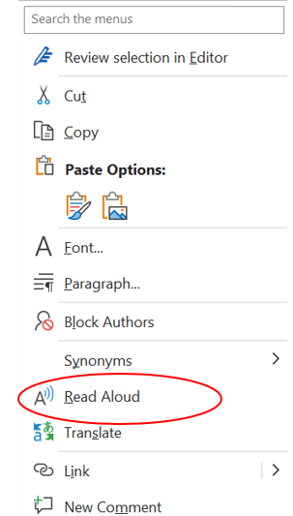

If users would like to read the entire document from a specific point, open the **Review** tab in Microsoft Word and then select **Read Aloud**. The voice speed can be adjusted by selecting the Voice Settings icon (speaker with gear icon) and positioning the slider, which offers 21 speeds. A male or female voice can also be selected.

If Microsoft Word is not connected to the internet, Read Aloud/Speak will still work, but only system voices will be available (Microsoft David, Microsoft Mark, Microsoft Zira), instead of the male/female voice options.

Read Aloud can also be added to the Quick Access toolbar for easy access by following these directions: [Use the Speak text-to-speech feature to read text aloud - Microsoft Support](https://support.microsoft.com/en-us/office/use-the-speak-text-to-speech-feature-to-read-text-aloud-459e7704-a76d-4fe2-ab48-189d6b83333c)

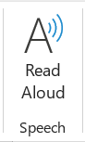 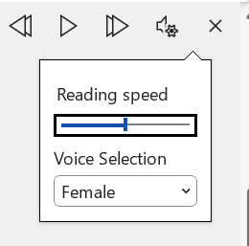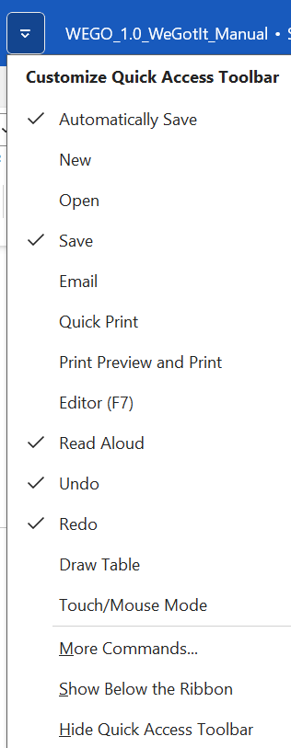

## Using Immersive Reader with WEGO

WEGO can be used with the built-in Immersive Reader tool to enable line focus (displaying 1-5 lines at a time), customize page color, enable wide spacing, enable syllables, and Read Aloud for the entire document. Users can edit text with Immersive Reader enabled. WEGO is not compatible with the Read Mode display setting for Microsoft Word.

# How to use WEGO: Step 1

To start using WEGO, open a WEGO template (Persuasive, Expository, Personal Narrative) in Microsoft Word. It is strongly recommended that users save a copy of the WEGO template with a different file name (e.g. WEGO_Student_Name) before they begin the writing process.

At the top of the screen, type in the name and date.

Next, type in a prompt for the essay. Prompts can be typed in advance and selected by the user, or users can type their own prompt or prompts to choose from.

After choosing the prompt, Step 1 is to **pick your goal**, which is done before writing and helps to guide the next steps. The user will pick a goal from the drop-down menu that appears when the phrase “Choose your goal here!” is selected. Three reasons must be included, but the user may choose to include one example, two examples, or three examples.

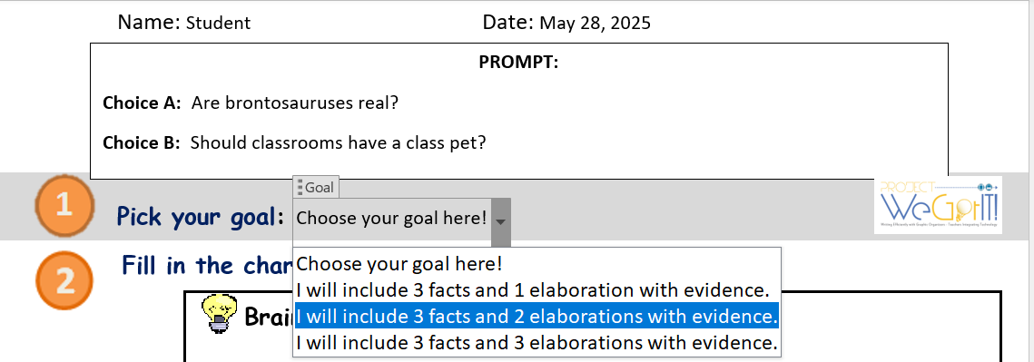

All white rows must be completed, while the gray rows correspond to the goal set by the user. If the goal is to include 3 facts and 1 elaboration, fill out one elaboration row. If the goal is to include 3 facts and 2 elaborations, fill out two elaboration rows. If the goal is to include 3 facts and 3 elaborations, fill out all three elaboration rows.

# How to use WEGO: Step 2

To view an example of a completed chart, select **Click here to see an example** within the WEGO document.

Brainstorm ideas

In the **Brainstorm** box, write down some ideas in response to the prompt inside of the text field. Words or brief phrases are appropriate, and it helps to separate ideas with a colon (:) or semicolon (;) so they do not get mixed up.

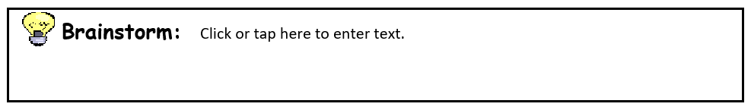

Organize IDEAS

WEGO uses a computer-based graphic organizer (CBGO) that uses the **IDEAS** strategy to support writers as they organize their thoughts and write. Each row of the CBGO incorporates a specific part of the IDEAS mnemonic:

* A screenshot of a cell phone

  AI-generated content may be incorrect.I: Identify your opinion | Identify your claim | Introduce hook
* D: Determine 3 reasons | Determine 3 facts | Describe 3 events
* E: Elaborate with examples | Elaborate with evidence | Elaborate with details
* A: Add transition words as you go!
* S: Summarize | Story takeaway

If the user needs a reminder for what to write for each row, they can hover the mouse/cursor over the phrases in the **IDEAS** column as well as over the headings in the CBGO (Brainstorm, Main Points, Sentences, Check Your Work) to see a pop-up window with text clarifying what needs to go into that row. WEGO also offers embedded human-read audio comments that can provide additional information.

## List main points

Using the keywords from the **Brainstorm** box, arrange words or phrases in the **Main Points** column. Users can write new ideas, copy and paste from the **Brainstorm** box, or highlight and drag words/phrases from the **Brainstorm** box into the new section (removing them from the **Brainstorm** box in the process).

Users can hover the mouse/cursor over the sections in the **Main Points** column to see a pop-up window with text clarifying what to write for each section.

Create sentences

Use the keywords and phrases from the **Main Points** column to write complete sentences in each row. Each sentence must start with a capital letter and end with a period or any other ending punctuation mark.

Before writing a sentence, select **Choose an item** to add a transition word or phrase to the beginning of the sentence. Once a word is chosen, select **Click or tap here to enter text** to continue writing.

## Check your work

During the writing process, use the **Check your work** column to monitor progress and make improvements as needed. Examples of checkbox prompts include:

* A screenshot of a survey

  AI-generated content may be incorrect.I included my opinion
* I included 3 reasons to support my opinion
* I have as many examples as I planned to have in my goal
* I have proper transition words
* I summarized my opinion.

# How to use WEGO: Step 3

All of the text in the **Sentences** column is outlined in an orange box. Select all of the content within the orange box and use the keyboard shortcut **Control+C** (**Command+C** for Mac) to copy the text. Alternatively, right-click or long-press on the selected text and select **Copy**.

Make sure to only highlight the sentences in the orange box─ do not highlight or copy any other parts of the graphic organizer.

# How to use WEGO: Step 4

After copying the **Sentences** column, place the cursor inside of the other orange box located in Step 4. Right-click inside of the box and select **Paste as text** to copy all of the sentences into one place. Another option is to use the keyboard shortcut **Control+V, A** to paste as plain text.

Each sentence will appear on a single line. Use **Backspace** to rearrange the sentences into one paragraph, taking care not to erase any punctuation. If needed, delete the placeholder text that may appear from unfilled gray rows.

After reading the completed essay, make any additional edits as needed. For easier editing, use the **Read Aloud** tool to listen to text─ see Enable text-to-speech and Read Aloud for more details.

# How to use WEGO: Step 5

After finishing the essay, use the **Evaluation** section to provide feedback. To determine the word count, select the text displayed in **Step 4** and view the word count in the status bar of Word located in the bottom left corner. Alternatively, use the keyboard shortcut **Alt+R, W** to view the word count dialog box.

